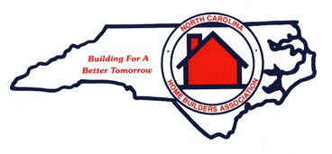NORTH CAROLINA
HOME BUILDERS ASSOCIATION

Maureen Mullen
Phone: | 919-676-9090
Toll Free: | 800-662-7129
Fax: | 919-676-0402

Director of Membership Services

5580 Centerview Dr., Suite 415
Raleigh, NC 27606
P.O. Box 99090 (mail) Raleigh, NC 27624-9090

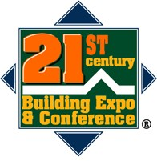Email: mmullen@nchba.org www.21buildingexpo.com
www.nchba.com

